Batch: A2 Roll No.: 16010122034

Experiment No. 7

Grade: AA / AB / BB / BC / CC / CD /DD

Signature of the Staff In-charge with date

Title: Implementation of Stack applications.

Objective: To implement applications of stack

Expected Outcome of Experiment:

CO | Outcome
1 | Explain the different data structures used in problem solving

Books/ Journals/ Websites referred:
- Fundamentals Of Data Structures In C – Ellis Horowitz, Satraj Sahni, Susan Anderson-Fred
- An Introduction to data structures with applications – Jean Paul Tremblay,
Paul G. Sorenson
- Data Structures A Pseudo Approach with C – Richard F. Gilberg & Behrouz A. Forouzan
- https://www.cprogramming.com/tutorial/computersciencetheory/stack.html
- https://www.geeksforgeeks.org/stack-data-structure-introduction-program/
- https://www.thecrazyprogrammer.com/2013/12/c-program-for-array-representation-of-stack-push-pop-display.html
- https://www.geeksforgeeks.org/check-for-balanced-parentheses-in-an-expression/

Assigned Stack application:
Balance of Parentheses

Algorithm:
- Declare an empty stack.
- Now start traversing the input string.
  - If you come across an opening bracket while traversing the string, add it to the stack.
  - Else the current character is a closing bracket. In this case, check to see if the top element of the stack is of the corresponding opening type and if it is then pop the top element from the stack and if not, then return false.
- If the stack is empty after traversing the string, return true; otherwise, return false
Example
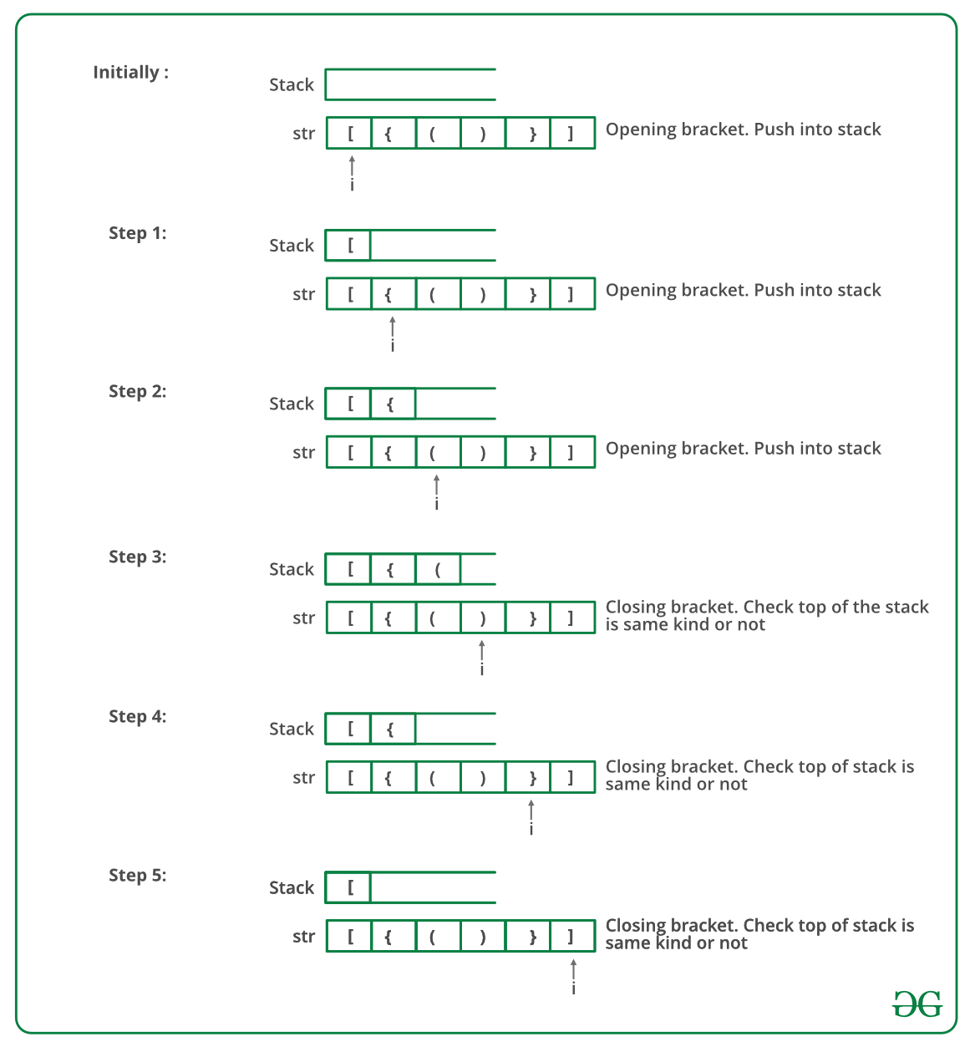

Source Code:
#include <stdio.h>
#include <string.h>

#define MAXSIZE 100
#define TRUE 1
#define FALSE 0

// Structure defining Stack data structure
struct Stack {
int top;
int array[MAXSIZE];
} st;

/*
Initializes the top index to -1
*/
void initialize() {
st.top = -1;
}

/*
Checks if Stack is Full or not
*/
int isFull() {
if(st.top >= MAXSIZE-1)
return TRUE;
else
return FALSE;
}

/*
Checks if Stack is Empty or not
*/
int isEmpty() {
if(st.top == -1)
return TRUE;
else
return FALSE;
}

/*
Adds an element to stack and then increment top index
*/
void push(int num) {
if (isFull())
printf("Stack is Full...\n");
else {
st.array[st.top + 1] = num;
st.top++;
}
}

/*
Removes top element from stack and decrement top index
*/
int pop() {
st.top = st.top - 1;
return st.array[st.top+1];
}

int main() {
char inputString[100], c;
int i, length;
initialize();
printf("Enter a string of paranthesis\n");
gets(inputString);
length = strlen(inputString);
/*
# for '{' : we push '{' in stack
# for '}' : we pop a character from stack. For every '}' there must be one '{' earlier.
This will ensure that
** There are equal number of '{' and '}' characters in string.
** For every '{' there is a '}' in input string later.

*/
for(i = 0; i < length; i++){
if(inputString[i] == '{')
push(inputString[i]);
else if(inputString[i] == '}'){
if (isEmpty()) {
printf("Stack is Empty...\n");
printf("InValid Paranthesis Expression\n");
return 0;
}
else {
pop();
}
}
else {
printf("Error : Invalid Character !! \n");
return 0;
}
}

if(isEmpty())
printf("Valid Paranthesis Expression\n");
else
printf("InValid Paranthesis Expression\n");

return 0;
}

Output Screenshots:
Example 1:
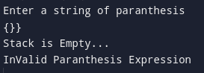
Example 2:
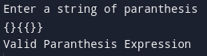
Conclusion:
Therefore the Checking of the balance of parentheses pairs in the given string was done successfully.

